Web Services

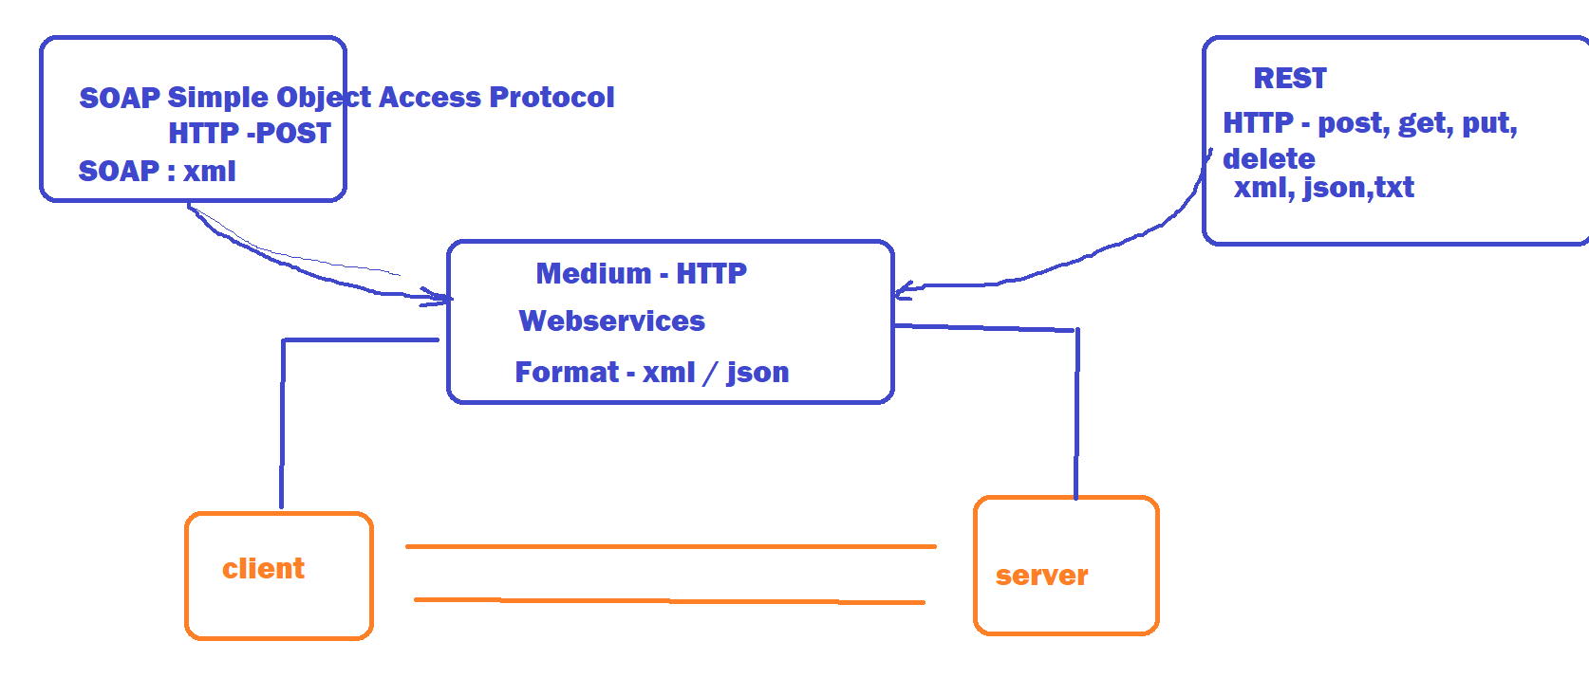

High level Architecture:

----------------------

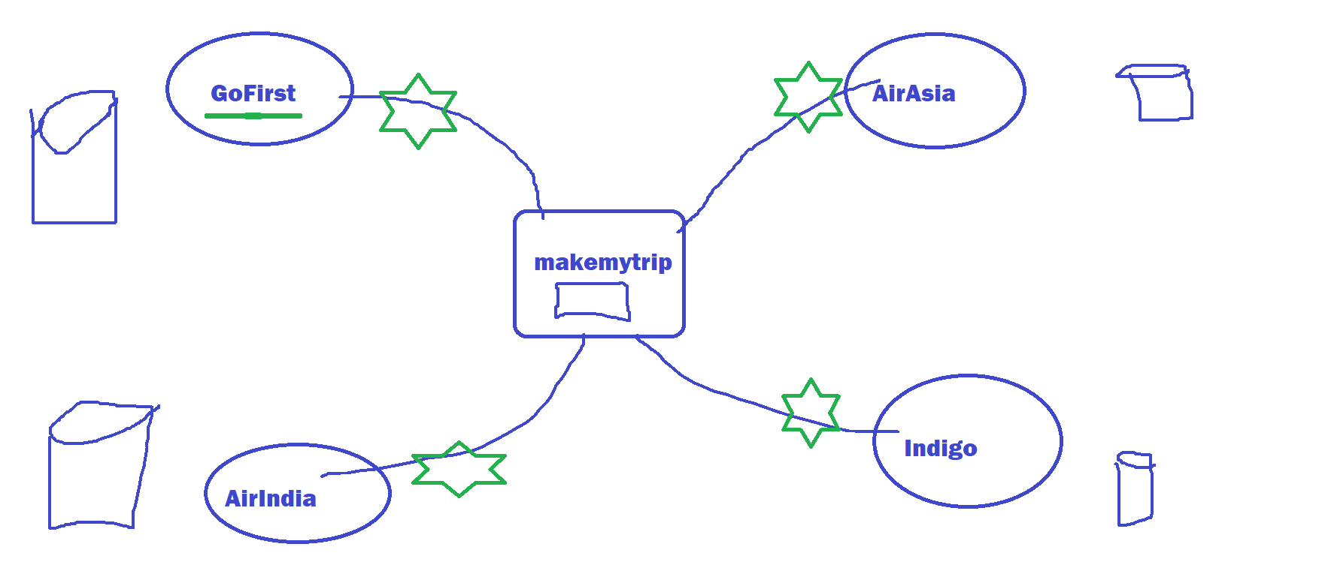

Client – Service consumer

Server – Service provider . Webservices acts as a communication media. WebServices are developed or implemented by webservice providers and makes it available over the internet.

Two major factors :

1. Medium – HTTP
2. Format – xml or json

If you are a service consumer and if you want to use WebServices you should know some of the details about the webservies like

1. What the web services are
2. Components
3. Functions
4. Praramenters
5. Return type

WSDL(WebService description language) is a document which contain all the above information.

UDDI – Universal Description Discovery and Ingegration

SOAP WebService :

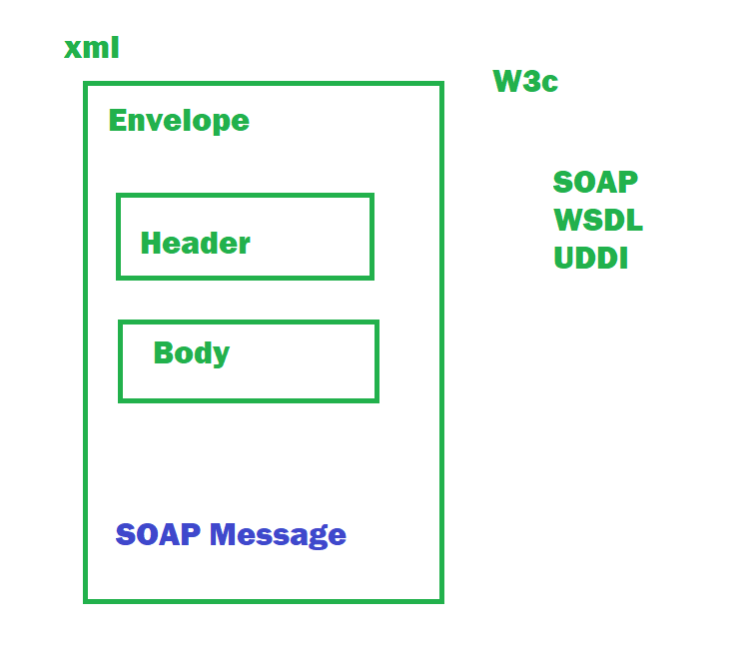

REST WebService :

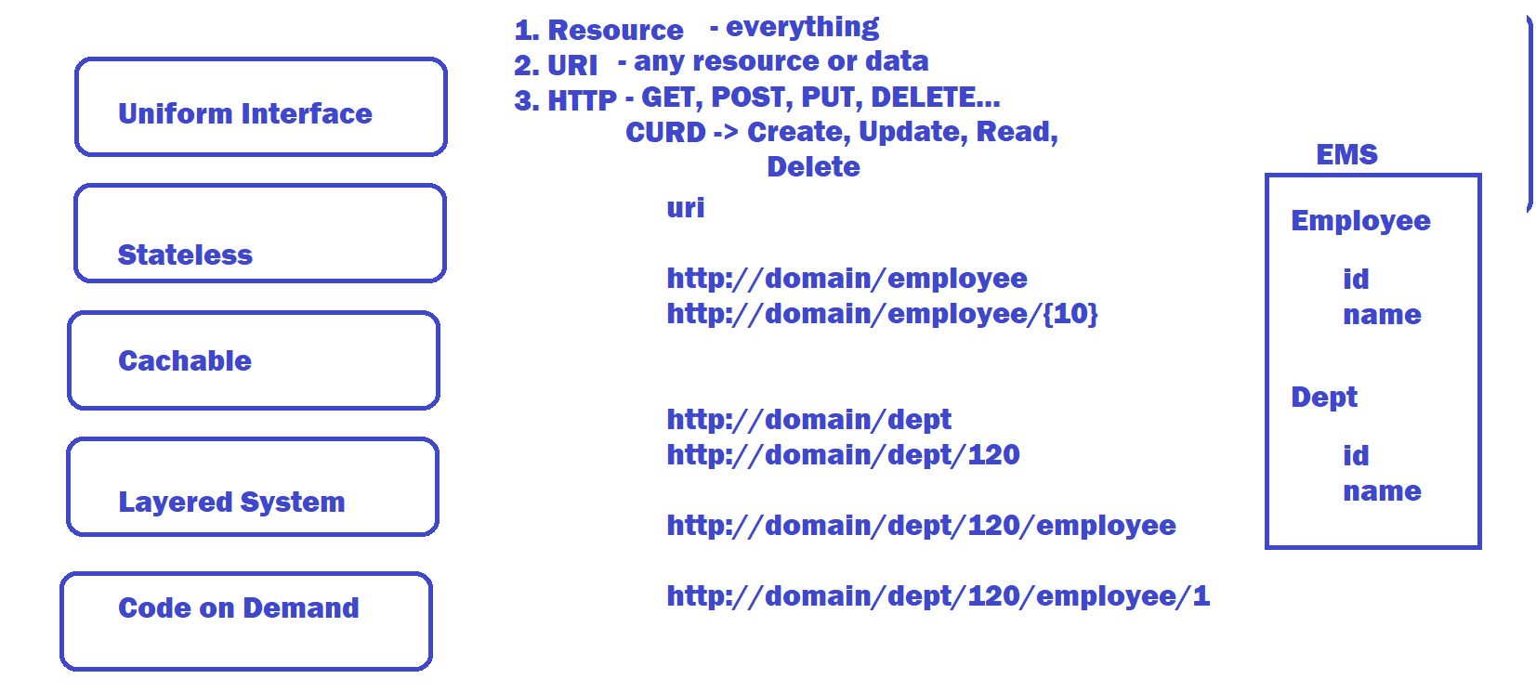

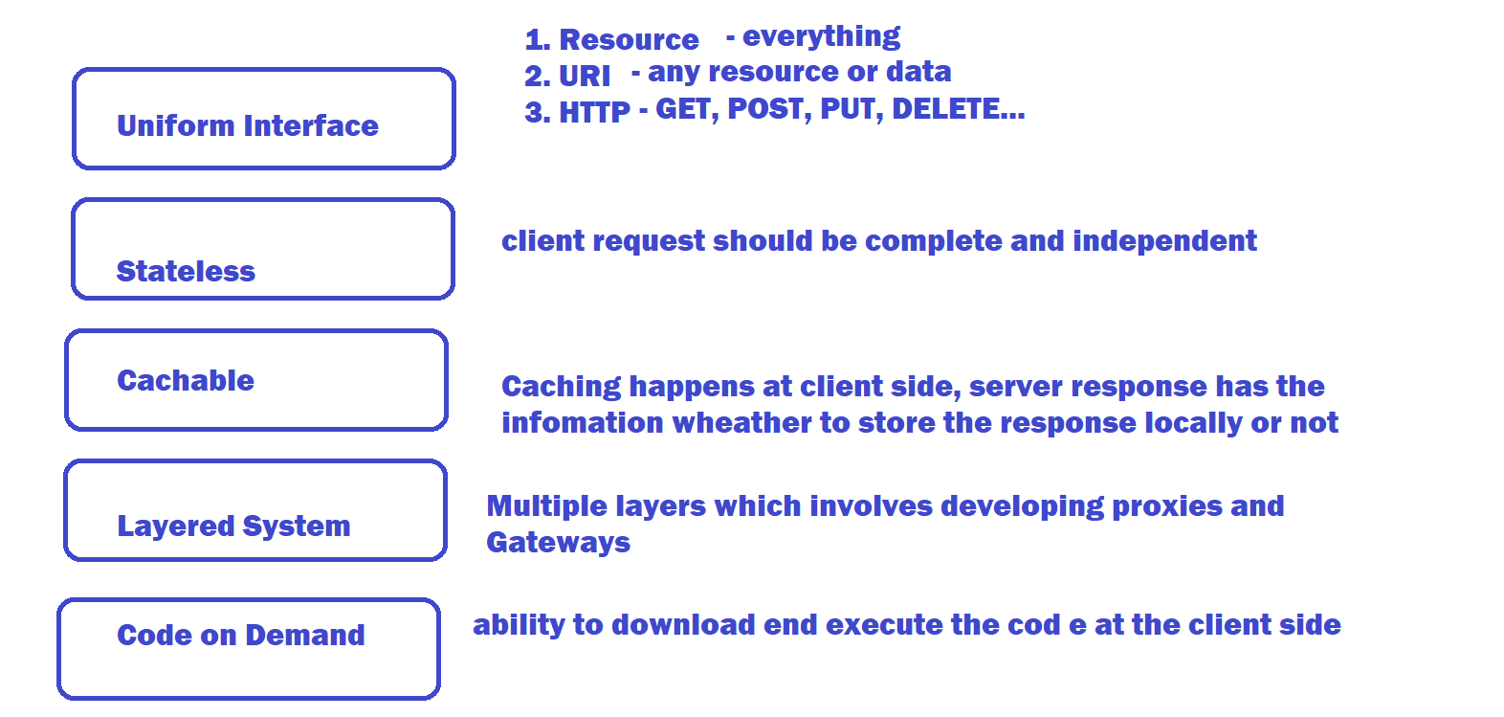

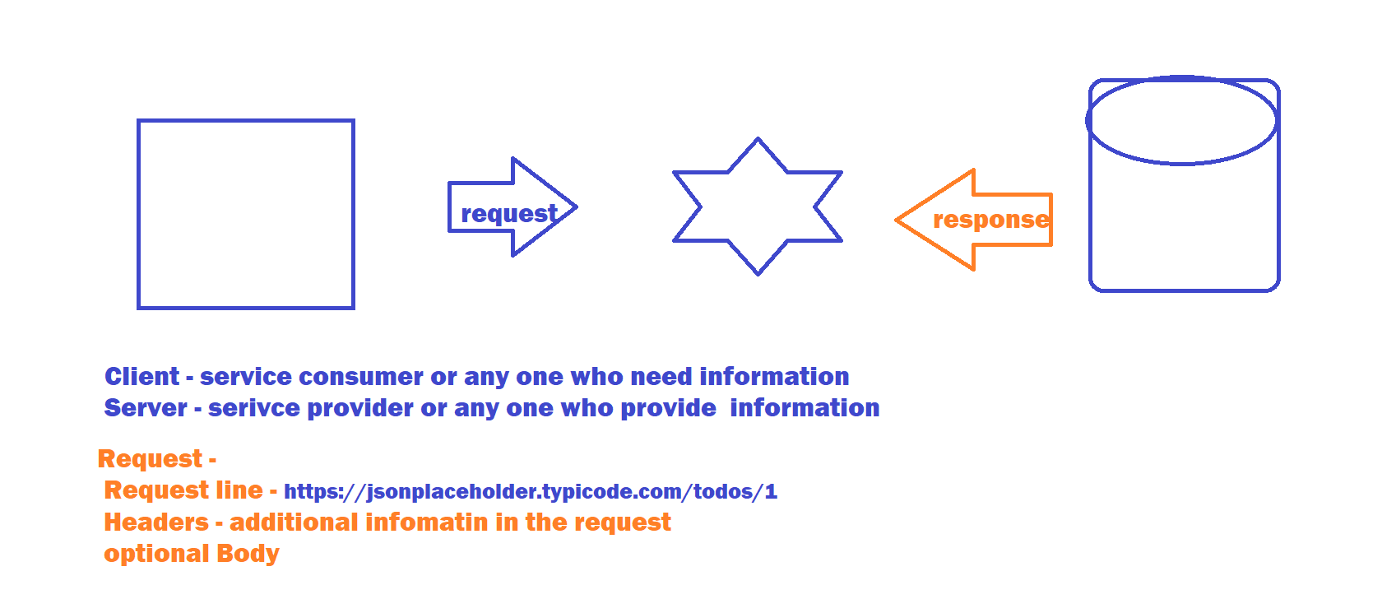

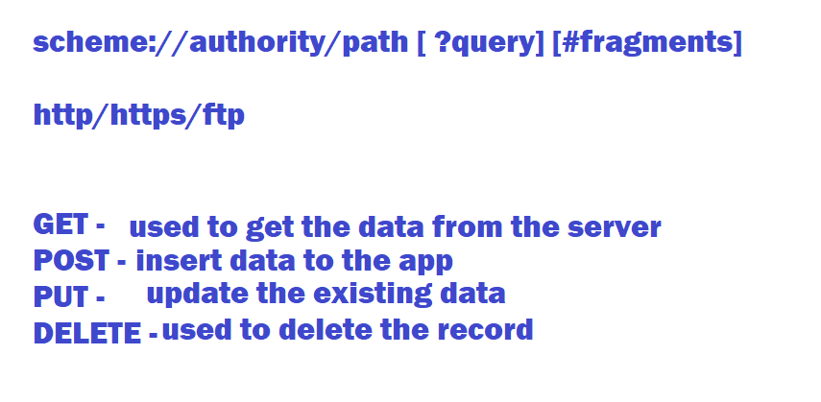

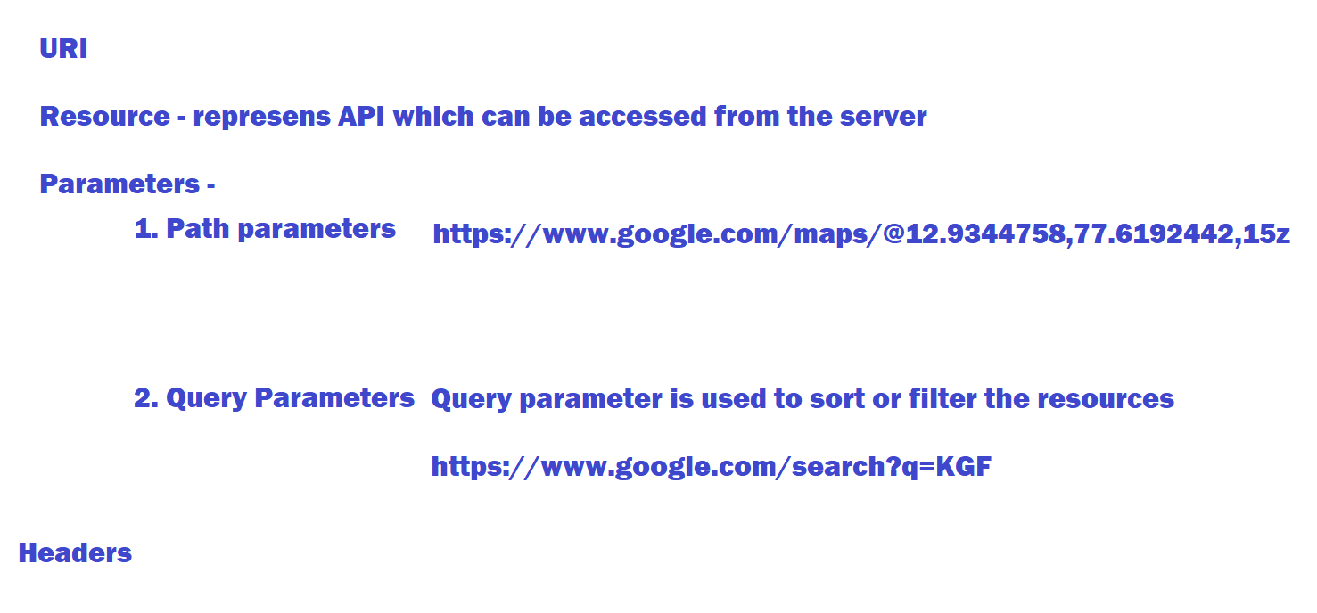

**Install PostMan**

* **GET**
* **POST**
* **DELETE**
* **COOKIES**
* **Global Variables** 
  + **Setting Global variable**
  + **Using Global variable**

**Trello Setup**

* **Register and Login to** [**https://trello.com/**](https://trello.com/)
  + **Create a board by clicking on Create button on top right corner in the home page**
  + **Create List**
  + **Create Tasks**
* **Login to developer website and get api-key and token**
  + [**https://developer.atlassian.com/**](https://developer.atlassian.com/)
  + **Go to** [**https://trello.com/app-key**](https://trello.com/app-key) **and get the api key**
  + **Click on generate token on the above page to get the token**

**Git HUB Automation**

* **Create a git hub account**
* **Go to** [**https://docs.github.com/en/rest/reference/repos**](https://docs.github.com/en/rest/reference/repos)
* **Start using the APIs**
* **Precondition : it should have token generated.**
* **STEPS to generate token :**
  + **Login to github**
  + **Go to settings 🡪 developer settings 🡪 click on personal access token 🡪 Generate new token**

**Automation using Rest Assured:**

**REST Assured is a java DSL for Automating REST APIs, Rest Assured Supports HTTP Methods like GET, POST, PUT , DELETE etc…**

**Configure Rest Assured**

1. **Download and install JAVA 1.8 or above**
2. **Set the Environment Variables**
3. **Eclipse or any other Editor**
4. 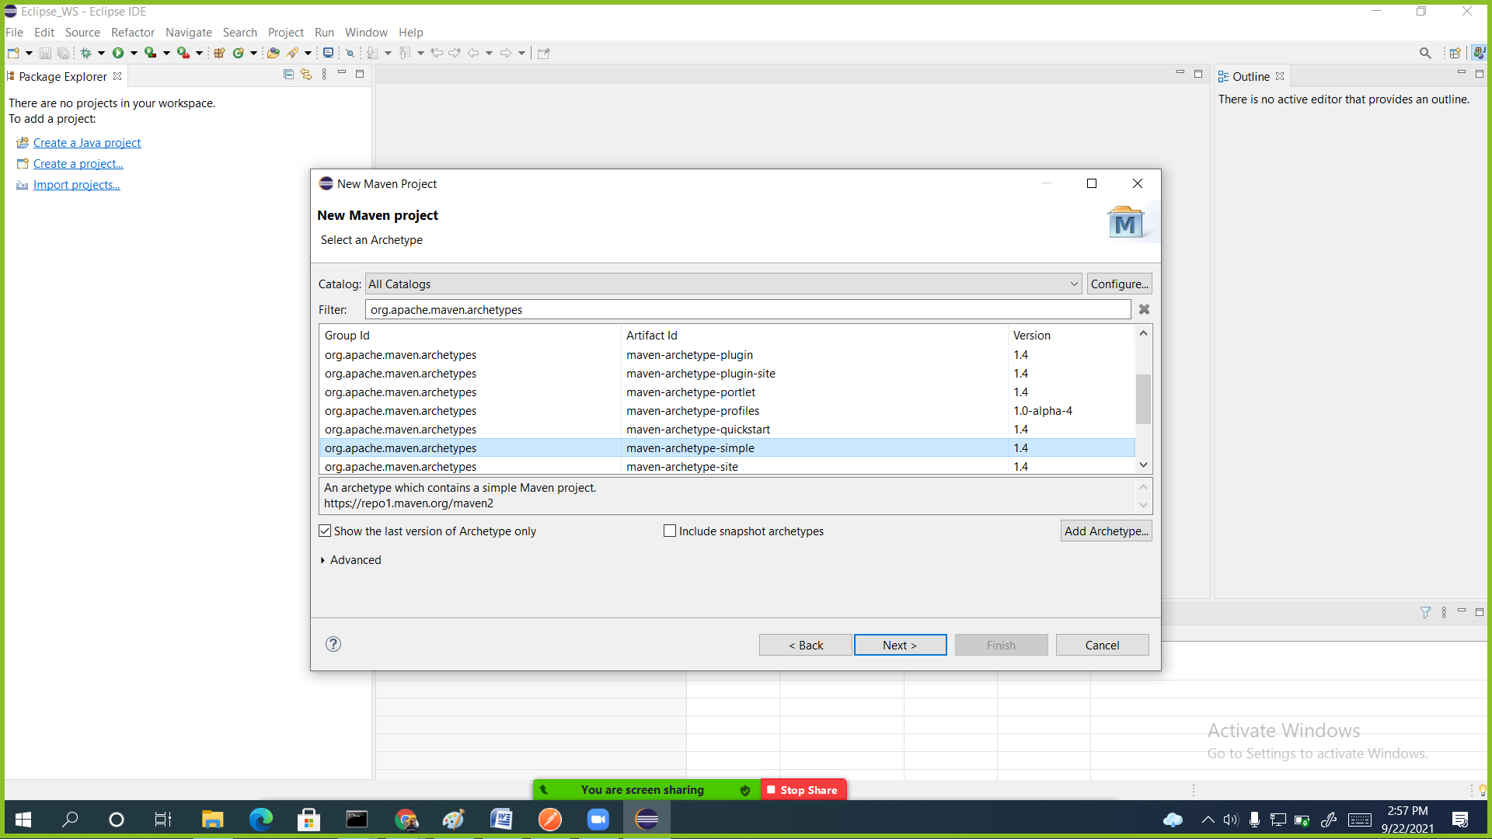
5. **Rest Assured Methods**
   1. **given()**
      1. **Request Header**
      2. **Parameters**
      3. **Cookies**
   2. **When()**
      1. **Get**
      2. **Post**
      3. **Put**
      4. **delete**
   3. **then()**
      1. **Assertion for response here**
   4. **Extract()**
      1. **Read the response object**

**Static imports :**

**Validate Response**

1. **JsonPath - Java**
2. **JayWay – Groovy**